Level 18 -> Level 19

The goal of this level is to enter into the home directory and read the readme file and get the password to the next level.

But the main issue is that we are unable to log in to level 18 with SSH because **.bashrc has been modified** to log us out when we try to log in with SSH. Thi s modification logs us out as soon as our ssh command completes.

**.bashrc** file determines the behaviour of interactive shells. It initializes an interactive shell session.

We can use the command: **ssh -t bandit18@localhost cat readme** where -t option is used to open the pseudo terminal which will easily connect to level 18 and directly print the content of readme file.

Or simply we can use **ssh bandit18@localhost cat readme (include our query with connection command)** without -t option so that as soon as our command complete, we can get the required content even if we log out from the bandit18@localhost after that.

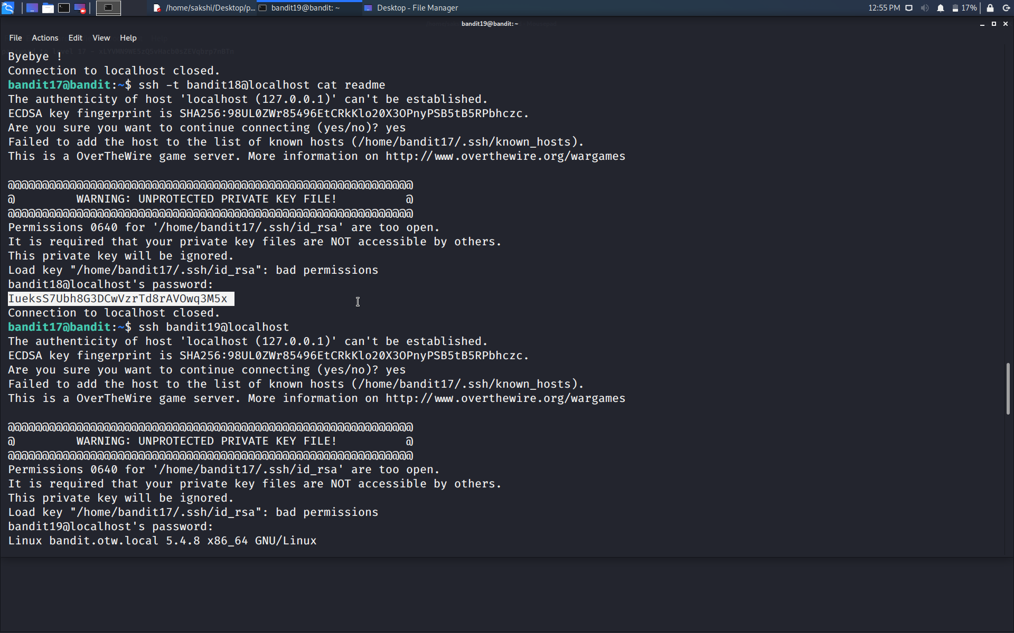

Use the command **ssh bandit19@localhost** to connect to the level 19.

Enter the password and hit enter.

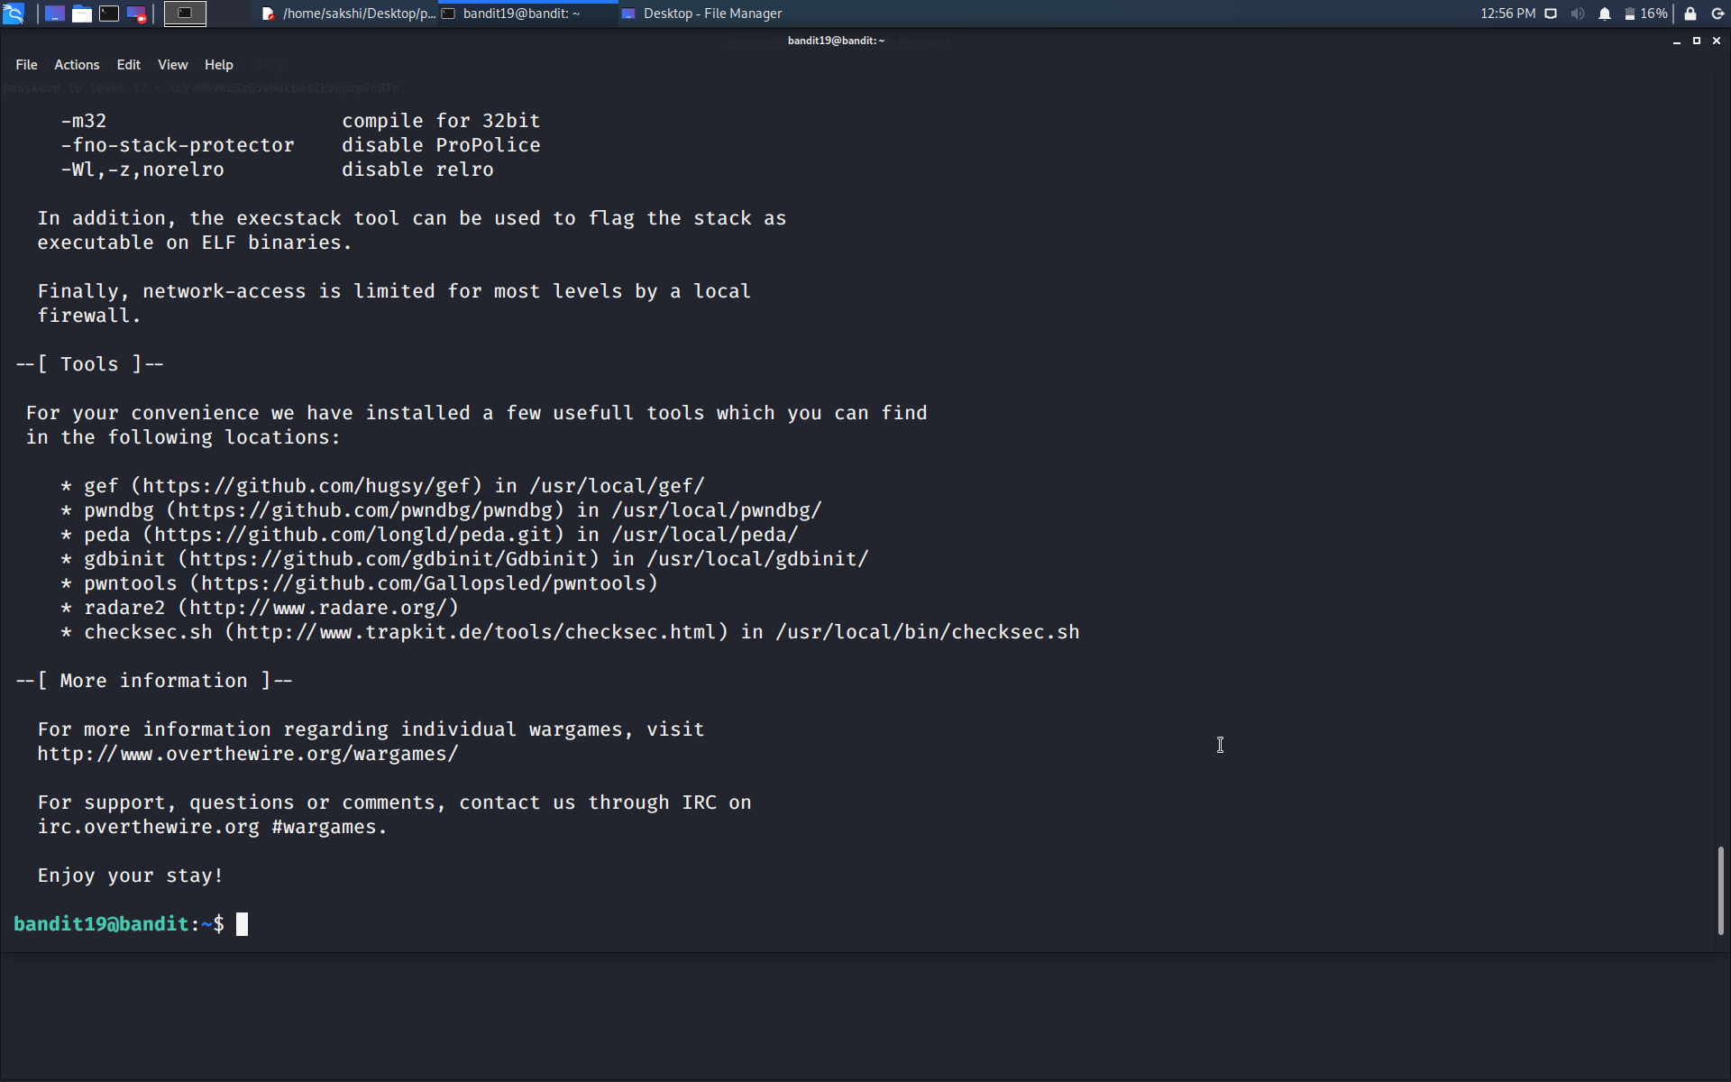

Successfully passed level 19.…